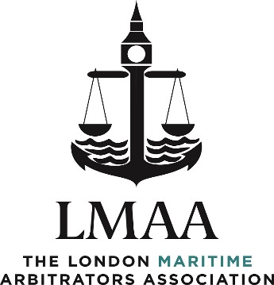

IDRC | 1 Paternoster Lane | London EC4M 7BQ

**APPLICATION FOR ASPIRING FULL MEMBERSHIP**

I, ……………………………………………………………………………………………………………………………………………………………..

**(Full Name in block letters)**

**(Profession or Occupation)** ………………………………………………………………………….......................................... ,

wish to apply for Aspiring Full Membership of the London Maritime Arbitrators Association. If elected, I agree to be bound by the Rules of the Association.

*It should be noted that the Aspiring Full Members list is intended (and to be perceived) as an upward escalator to promote the development of AFM’s practices towards full membership, though the responsibility remains with the AFM to develop their practice. As such, the Association will look to monitor the development of those practices and expect the AFMs to provide regular updates on the numbers of appointments, hearings etc.*

**Address, Telephone Number, Email and Website (if applicable)**

………………………………………………………………………………………………………………………………………………………………..

………………………………………………………………………………………………………………………………………………………………..

………………………………………………………………………………………………………………………………………………………………..

1. **Date of Birth:** ………………………………………………………………………………………………………………………………

2. **Position Presently Held:** ………………………………………………………………………........................................

…………………………………………………………………………………………………………………………………………………….

3. **Qualifications (e.g. Honours/JP/Degree(s)/Membership of Other Institution/etc.):**

(a) abbreviated title (b) title in full

………………………. ………………………………………………

………………………. ………………………………………………

………………………. ………………………………………………

4. **Any particular branch of shipping in which the applicant has obtained specialist knowledge:**

…………………………………………………………………………………………………………………………………………………….

…………………………………………………………………………………………………………………………………………………….

…………………………………………………………………………………………………………………………………………………….

5. **Extent and nature of arbitrations conducted by the applicant as arbitrator:**

**(Please complete Excel spreadsheet)**



6. **Names and Addresses of two Referees to whom enquiry may be made:**

…………………………………………… ………………………………………………

…………………………………………… ………………………………………………

…………………………………………… ………………………………………………

…………………………………………… ………………………………………………

…………………………………………… ………………………………………………

I ATTACH HERETO:

**(i) A COPY OF MY CV**

**(ii) ONE OR MORE SPECIMEN AWARDS DRAFTED**

**Signature** …………………………………………. **Date:** ………………………………………………

***BY SIGNING THIS DOCUMENT, I AGREE TO GIVE CONSENT ALLOWING THE LMAA TO HOLD THE ABOVE INFORMATION ABOUT ME IN ACCORDANCE WITH THE 2018 GDPR REGULATION***